Ch.24 Web of Life.
Case study
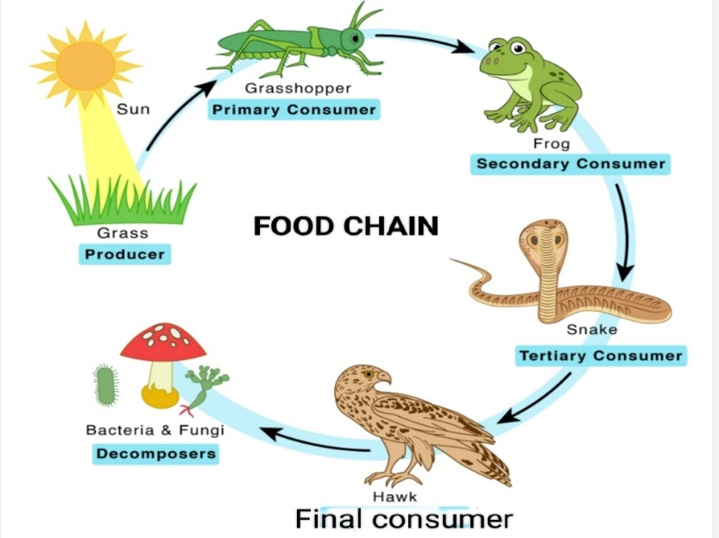

a. In the food chain which group is represented by herbivorous animals.
b. In a food chain, ______ and ________ is passed from one organism to another.
c. If primary consumers are removed from the food chain, mention the effect that will happen in food chain.
d. Make a food chain by arranging the given organisms :
